**PCR**

***Polymerase Chain Reaction***, or ***PCR***, is a standard technique in all molecular biology labs for amplifying fragments of DNA. The DNA fragments usually consist of one or a few very specific sequences; sequence specificity is determined by the sequence of the ***primers*** that are added to the reaction. An enzyme called ***DNA polymerase*** performs the actual amplification. Repetitive cycles of copying the ***DNA template*** result in an exponential increase in the number of copies of DNA during the reaction. The cycles typically consist of three steps, 1) ***template denaturation***, 2) ***primer annealing***, and 3) ***extension***. This guide will first give an overview of a typical PCR reaction and define important terms. A general protocol will then follow, as well as a more in-depth description of how to identify a gene and design primers for specific & efficient amplification.

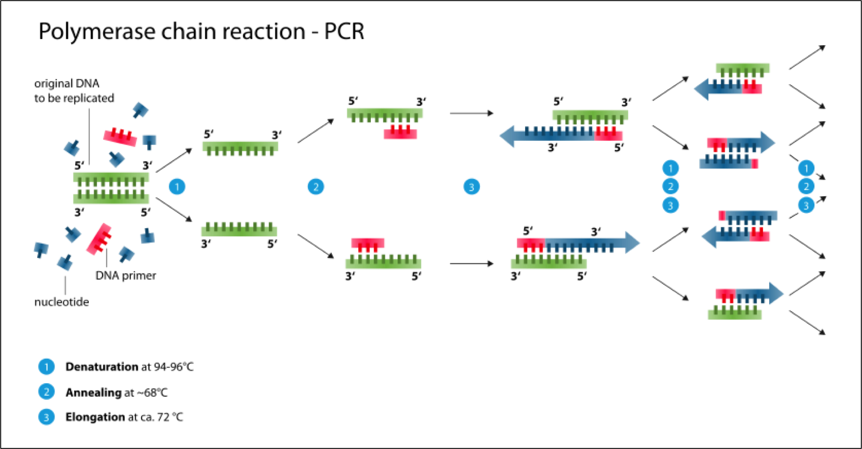

**PCR Overview**

As mentioned above, PCR consists of three main steps:

1. Template **denaturation** is the first step, and involves the melting of the double-stranded DNA template into two strands. This can be achieved by heating the reaction to about 92°C-98°C. Because the reaction needs to happen under such high temperatures, the DNA polymerase enzyme needs to be thermostable, or heat-stable.
2. The next step in PCR is primer **annealing**. Primers, also known as oligonucleotides, are short (<50) single-stranded lengths of nucleic acids that act as a starting point for the DNA polymerase. Primers should at least partially match the DNA template of interest, by at least 18 nucleotides, and the forward and reverse primers should flank the DNA segment to be amplified. The primers are said to be ***complementary*** to their matching region on the DNA template. Every primer has a ***melting temperature***, or ***Tm***, and an ***annealing temperature***, or ***Ta***, and these temperatures determine the annealing temperature of the PCR reaction, although this might require some optimization. Generally, the annealing temperature of the PCR reaction should be 3-5°C less than the annealing temperature of the primers, and each primer in a pair should within 5°C of each other. A good annealing temperature is usually in the range between 54-60°C. Primers are added well in excess of what is needed to ensure that only the primers bind to the template, and that the template strands don’t reanneal to each other. More detailed step-by-step guidelines for primer design are given at the end of this guide.
3. After the primers have annealed, or bound, to the DNA template, the next step is **extension**. This is when the free deoxynucleotides, or dNTPs (A, C, T, G, usually), in the reaction mix are added to the synthesized strands of DNA. Extension usually happens at around ~72°C, and the length of time depends on the length of the PCR product being amplified; the longer the PCR product, the longer the extension time. Most enzymes polymerize 1000 bases per minute. After the cycles are finished, there is usually a final extension step, typically lasting around 5-8min., to ensure that the finished product is complete. At this point, most thermocyclers can be programmed to store the reaction at 4°C for “∞” (or as long as the machine is still running uninterrupted).

The cycles of denaturation, annealing, and extension usually go from 20-35 cycles, although the cycles can go as far up to 45 in some cases. Theoretically, the more cycles, the higher the yield, but also the more chances for errors to occur in the final product; 30 cycles is a good place to start.

There are many different types of polymerase enzymes available the most common is Taq polymerase named for *Thermus aquaticus*(Taq). Most enzymes come in a Master Mix which contains everything they need to work. One of these necessary components is magnesium chloride (MgCl2), which Taq polymerase needs as a cofactor for optimal activity. 1.5mM MgCl2 is usually the best place to start, and is usually what is provided in 10X reaction buffers containing MgCl2; but certain reactions may require more or less. To play with the MgCl2 concentration, a 10X reaction buffer is usually also supplied that lacks MgCl2, along with a stock of by MgCl2 itself, so you can change the concentration to meet your needs. Too little MgCl2 will result in no PCR product, while too high could result in extra PCR products besides the one you want. If you find you need to test a range of concentrations, try as low as 0.5mM up to 4mM max.

Some 10X reaction buffers may also include dNTPs. They are usually added well in excess of what is needed to make the final product. The example reaction below is shown for a 10X reaction buffer that contains MgCl2, but lacks dNTPs, so the dNTPs are added separately.

**General PCR Protocol**

To prevent the enzymes from being active too soon, keep everything on ice before starting the reaction.

1. Add the following components to a PCR tube on ice:

When Using a Master Mix

|  |  |  |
| --- | --- | --- |
| **Component** | **Volume** | **Final Concentration** |
| **Water** | 37ul | - |
| **1-15uM forward primer** | 1ul | 300nM |
| **1-15uM reverse primer** | 1ul | 300nM |
| **DNA template** | 1ul | ~1ng-100ng |
| **5x Taq Master Mix** | 10ul |  |
|  | 50ul |  |

When Using Individual Components

|  |  |  |
| --- | --- | --- |
| **Component** | **Volume** | **Final Concentration** |
| **Water** | 21ul | - |
| **10mM dNTPs** | 1ul | 200uM |
| **10X reaction buffer w/ MgCl2** | 5ul | 1X, 1.5mM MgCl2* |
| **15uM forward primer** | 1ul | 300nM |
| **15uM reverse primer** | 1ul | 300nM |
| **DNA template** | 1ul | ~1ng-50ng |
| **Taq polymerase enzyme** | 1ul |  |
|  | 50ul |  |

*The exact concentration of MgCl2 in the final reaction can be tweaked to optimize; typically, the 10X reaction buffer can be provided without MgCl2, and MgCl2 can be added separately.

1. Tap the tube gently to mix, ensuring that the liquid is at the bottom of tube
2. Place the tube in a thermocycler
3. Program the thermocycler; exact cycling conditions will depend on the Taq, primers, DNA template and length of amplicon (aka the PCR product), but a general guideline is:

|  |  |  |  |
| --- | --- | --- | --- |
| **Step** | **Temp** | **Time** | **Cycle** |
| **Initial Denaturation** | 94°C | 2min. | 1X |
| **Denaturation** | 94°C | 15sec | 30X |
| **Annealing\*** | 51-60°C | 30sec |
| **Elongation** | 72°C | 45sec |
| **Final Elongation** | 72°C | 7min. | 1X |
| **Storage** | 4°C | ∞ | 1X |

*If you don’t know the annealing temperature starting with 55°C is always a safe way to go.

Following PCR, the amplicon will need to be purified before moving on to the restriction digest (see “Agarose Gel” guide and gel purification protocol in “Minipreps” guide).

**Gene Identification and Primer Design**

Good primer design is at the heart of any successful PCR reaction. The forward and reverse primer pair should be able to work together in the same reaction and only bind to the target sequence, not any non-specific sequences. The forward primer usually matches the top (***sense***) strand, while the reverse primer is the reverse & complement of a sequence matching the bottom (***anti-sense***) strand:

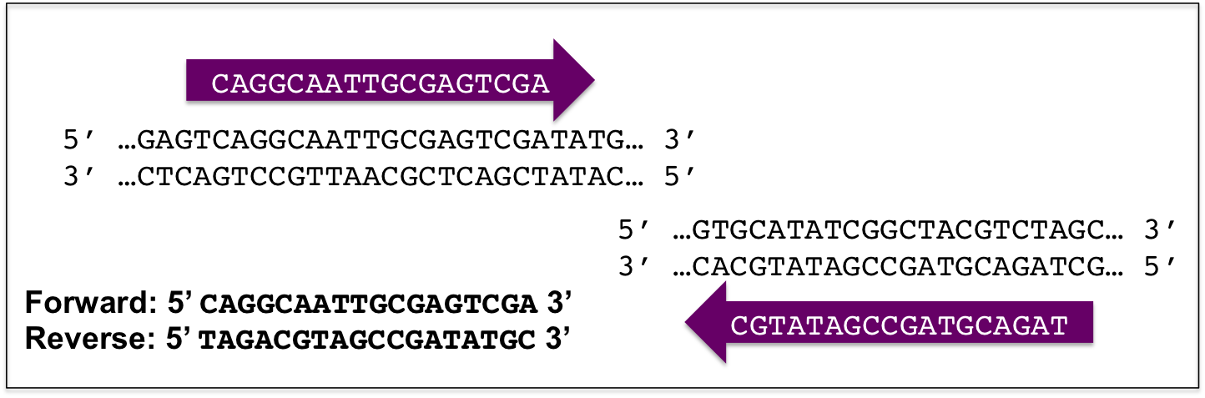

There are many primer design tools available for free online; the one used in the following example is Primer Blast, available from the NIH ([www.ncbi.nlm.nih.gov/tools/primer-blast/](http://www.ncbi.nlm.nih.gov/tools/primer-blast/)). These tools use algorithms that take into consideration some generally accepted guidelines for what makes a “good” primer, such as:

* GC content: between 40%-60%
* Length: between 18bp-22bp
* Primer melting temperature (Tm): between 52°C-58°C
* Primer pair Tm: primers used in the same reaction should have Tm within 5°C of each other
* A few G’s or C’s at the 3’ end of each helps the primers bind
* No internal binding of the primer to itself, or to each other
* Avoid too many repeats or runs of single bases, which can cause mispriming
* Amplicon (PCR product) length: 100bp-800bp

Of course, different situations may call for slightly different reaction conditions and primer design, so adjust accordingly.

To demonstrate the utility of PCR in molecular biology, the following guide will walk through the identification of the DNA sequence of a gene of interest using an online database and designing primers to efficiently amplify the target sequence.

Let’s say we want to study the function of the protein encoded by the APOE gene, which exists as three different versions based on one or two nucleotides being different from each other; the three different versions are ***isoforms*** of the same gene product. We have a sample of genomic DNA from a human subject, and we want to determine which isoform of APOE is in the sample. To do this, we first need to perform PCR to amplify the region of the gene that differs among the three isoforms, which happens to be in exon 4 of the gene (an ***exon*** is the part of the DNA that can be transcribed into RNA, while an ***intron*** is the DNA sequence in between the exons). Let’s assume we have everything we need to run the PCR assay: the purified sample of genomic DNA that we’re testing and all the reagents for the reaction; we just need to design and order the primers now.

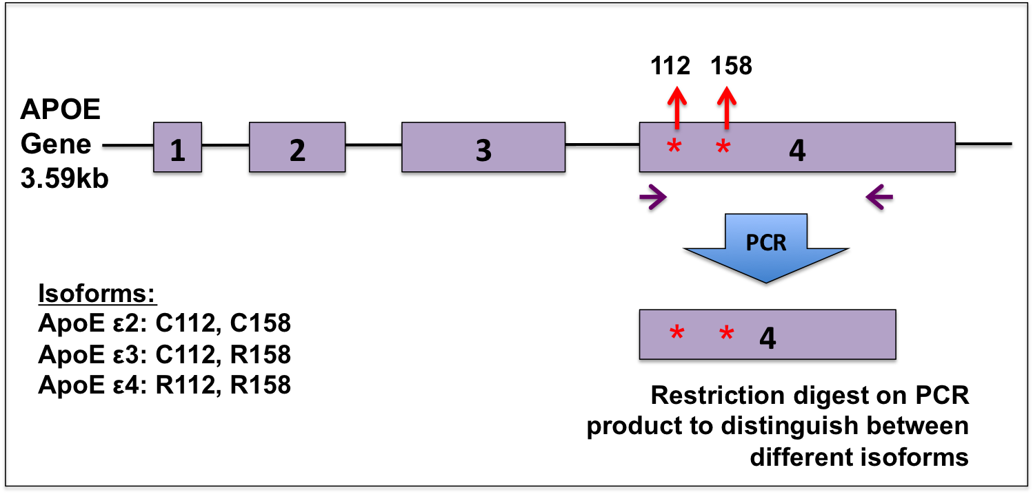

Structure of the APOE gene and overview of PCR strategy to amplify a section of exon 4. The APOE gene is displayed with the exons as purple boxes and the introns as lines connecting the boxes. The gene has three different isoforms, based on two single nucleotide differences at positions 112 and 158 (red stars) of the protein-coding sequence in exon 4: the ApoE ε2 isoform encodes a cysteine amino acid at both positions, the ε3 encodes a cysteine at 112 and an arginine at 158, and ε4 encodes an arginine at both positions. Primers (purple arrows) can be designed to amplify a piece of exon 7, which is 860bp long, and the PCR product can then be used in an assay to distinguish among the different isoforms, for example.

First we need to know the sequence of the DNA template to design primers for efficient amplification. For this, we can turn to the NCBI online database to find our gene of interest.

1. Go to NCBI:<https://www.ncbi.nlm.nih.gov>
2. Select “Gene” in the dropdown menu at the top left and enter in the name of the gene of interest, in this case, “APOE”; click the “Search” button at the right
3. A list of all the gene info related to APOE will appear; on the right-hand side you can filter the results based on taxon; select “Homo sapiens” for human genes.

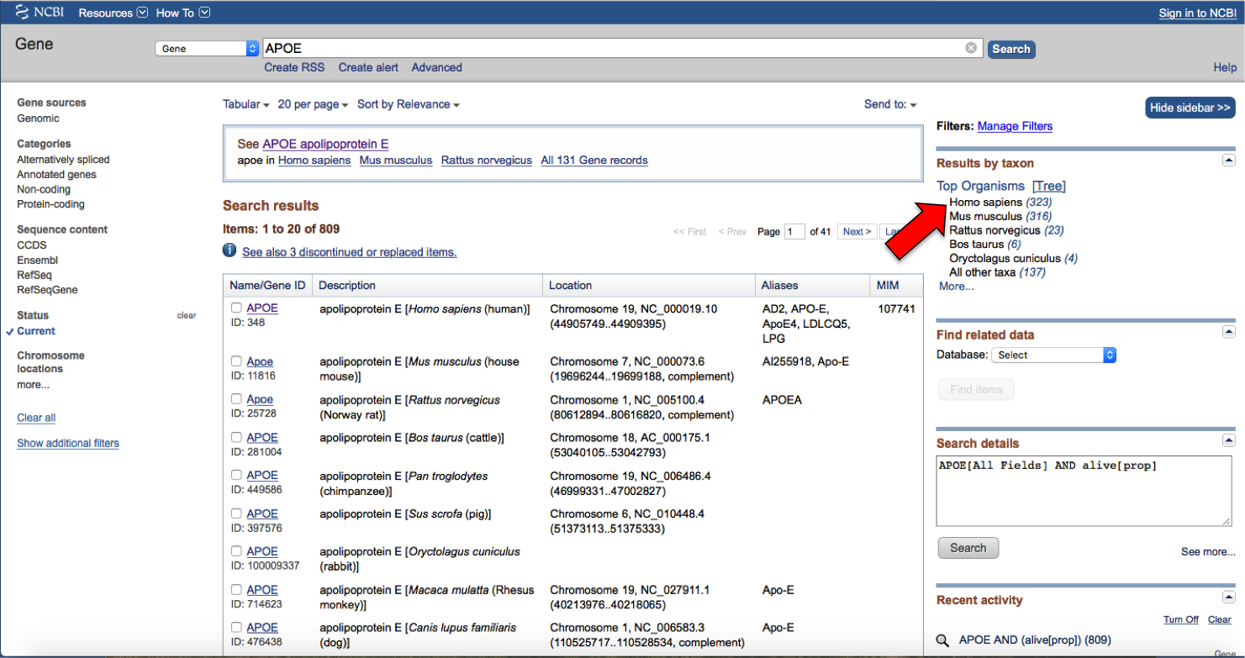

1. You’ll notice that a lot of genes are listed that aren’t the one we specified. Either the genes are nearby on the same chromosome, or the gene products are known to interact. Click the first entry, “APOE.”
2. Under the “Table of Contents” on the right-hand side, click “NCBI Reference Sequences (RefSeq)” to skip down to the sequence information.

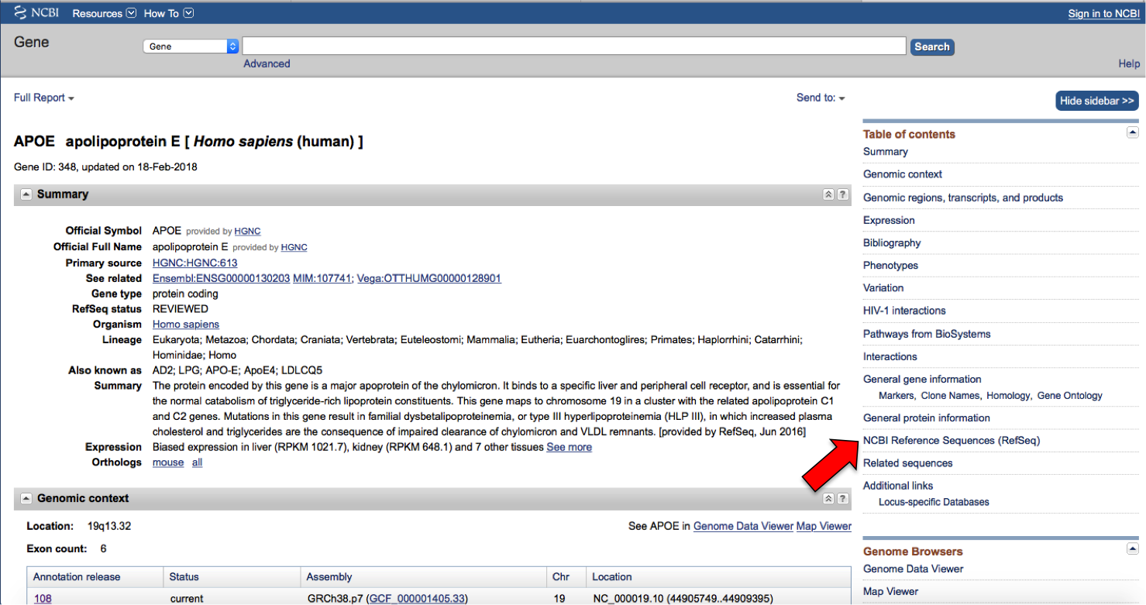

1. Click the “GenBank” link to get to the APOE sequence reference page.

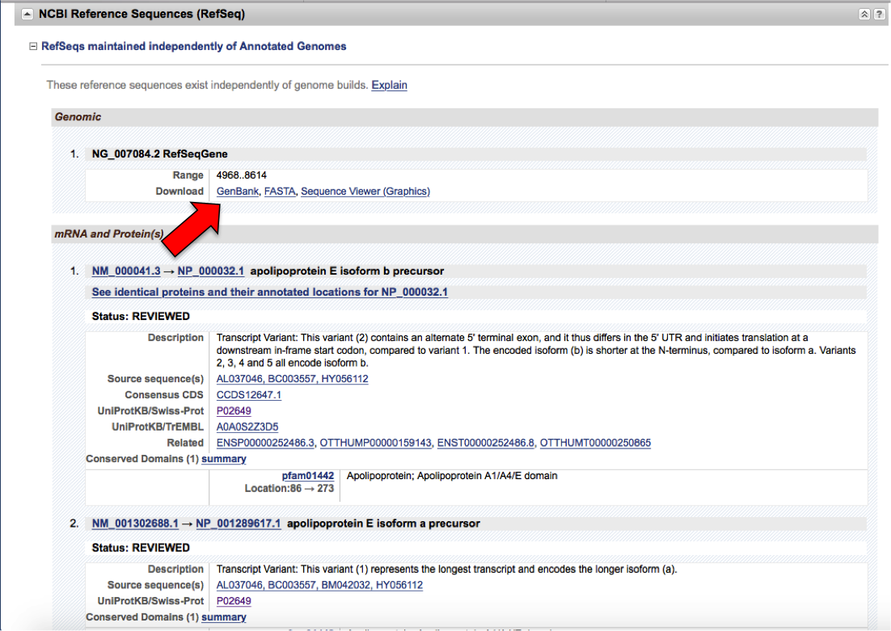

1. Here’s the GenBank entry on the human APOE gene; scroll down to check out some interesting tidbits, like the amino acid translation, and scroll all the way down to get the DNA sequence, which includes both introns and exons. Pretty cool, but the sequence alone doesn’t help us too much. Scroll back up to the top of the page and click the “Pick Primers” link at the right.

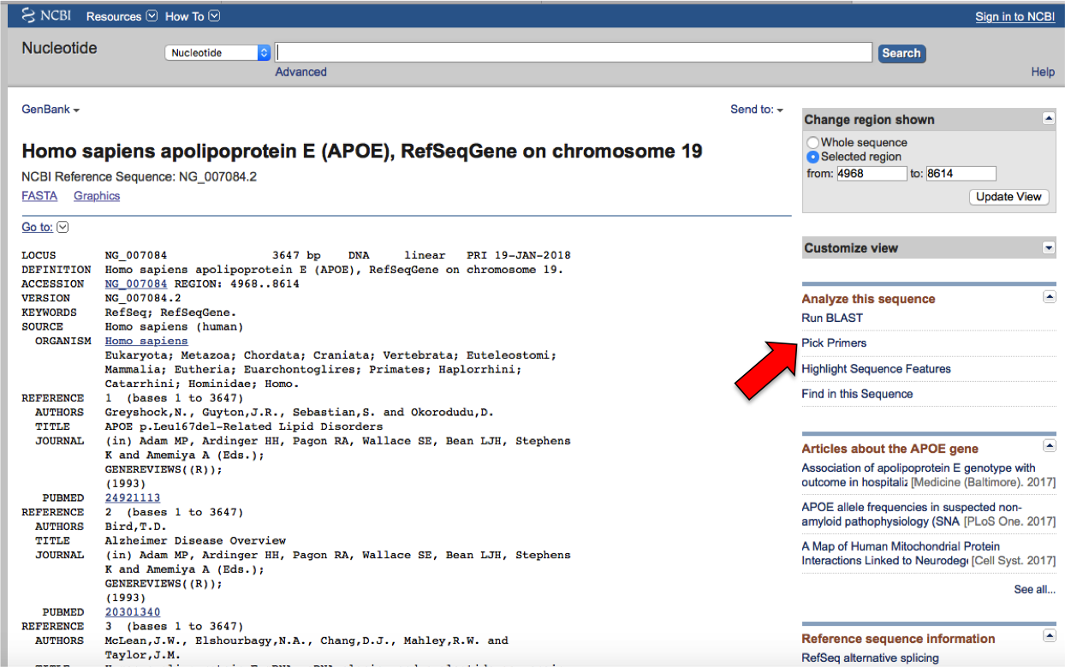

1. Now we’re in the NCBI Primer Blast tool, a free online tool to help design primers that are specific for an intended PCR target. The tool uses algorithms to screen primers against databases of known genetic sequences to avoid primer pairs that could cause non-specific amplifications. The tool can also be used the other way around, which is what we’re doing here: start with a known genetic target and find potential primer pairs that amplify a region of interest. To do this, the tool ensures that the primers fulfill general parameters that are known to result in good amplification. It already entered the accession number for the APOE sequence for you, and on the right of that is the range of the APOE gene that the tool will use to check for suitable primers, spanning the entire gene. We’ll get back to this in a minute.

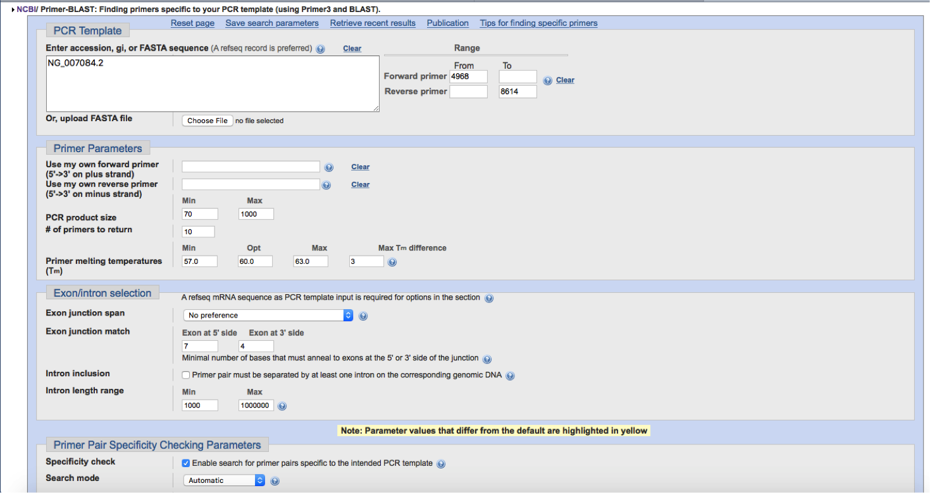

1. Keep all the default settings for now, but enter in “Homo sapiens” for the organisms, and to make it easier, you can click “Show results in a new window” and make sure “Use new graphic view” is also selected. Click “Get Primers.” This might take a few minutes.

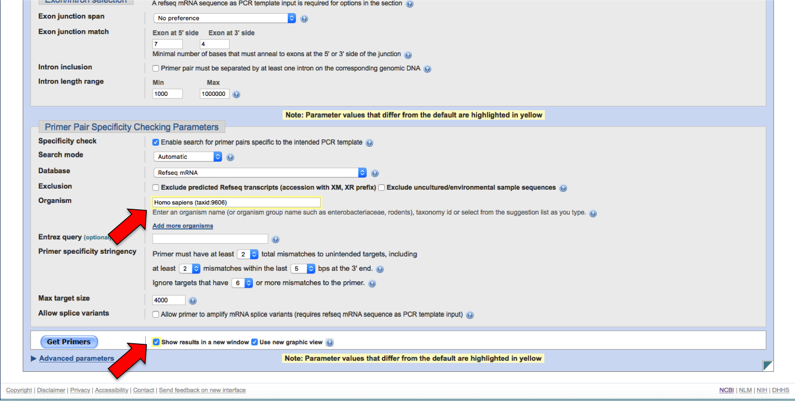

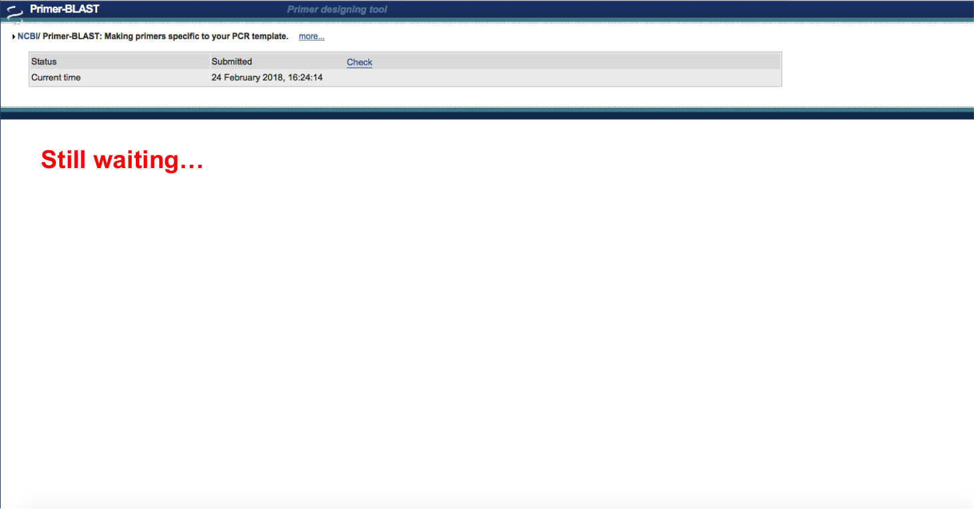

1. The results will be displayed first with a graphical view of the gene and the possible primer pairs that it liked; below this will be a detailed report of the possible primer pairs, including the size of the expected PCR product for each pair. In this case, it looks like the primer design tool preferred primer pairs that amplified across exon 3 and the intron between exon 3 and 4; not exactly the region we were hoping for. 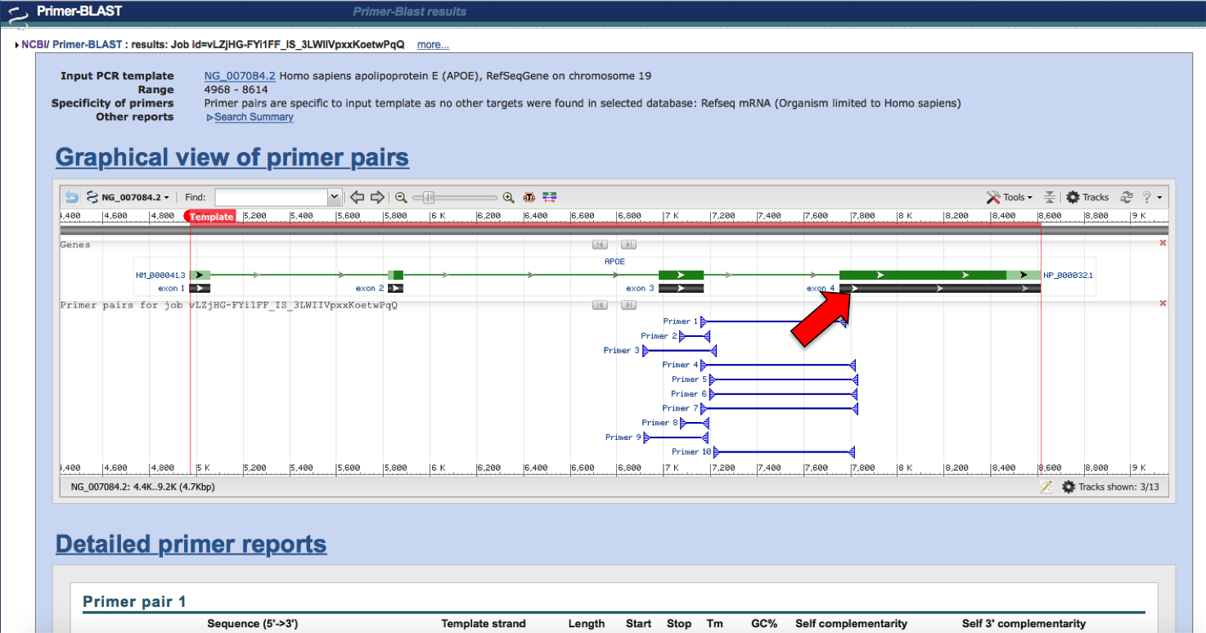

Scroll over exon 4, and a window will pop up with more detailed information, including the location, which is between 7752 and 8614.

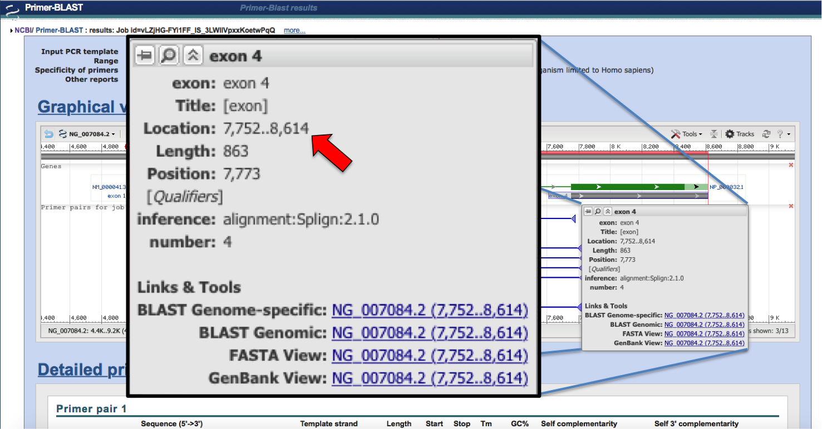

We can go back to the Primer Blast tool and use this location information to restrict our primer search to exon 4; enter “7752” as the starting point for the forward primer. Keep “8614” as the ending point for the reverse primer. Click “Get primers” again.

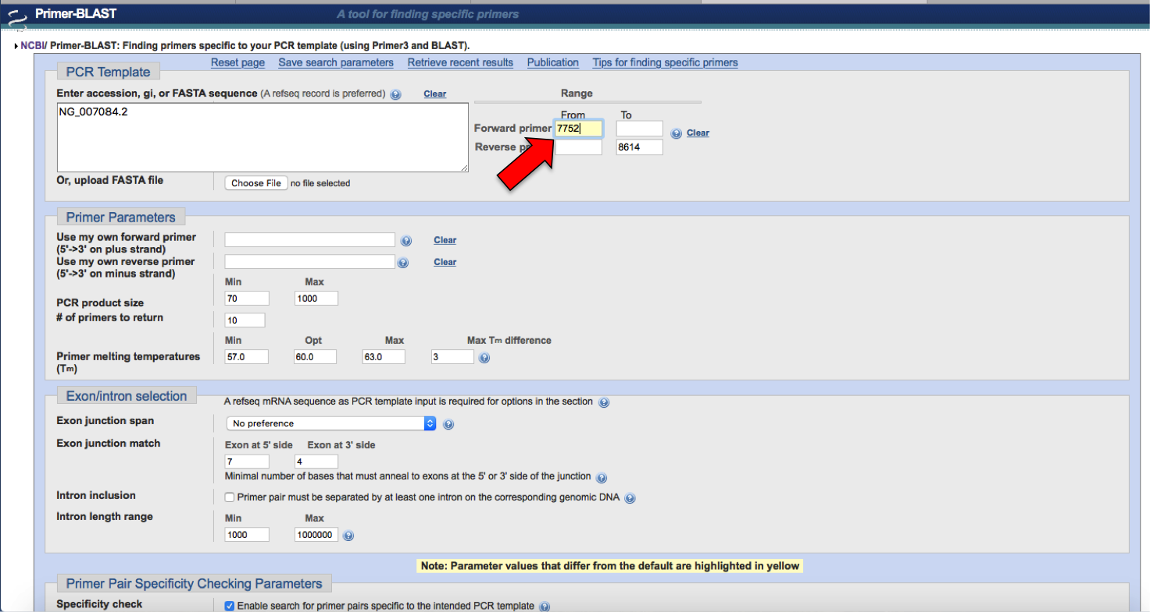

1. The tool found some records that match the region we specified; these records happen to be the mRNA sequences of the variants of APOE, which is good, because we wanted primers that could amplify all of the variants for our subsequent analysis. Click all of the additional APOE variants, and also make sure “Show results in a new window” is selected, and click “Submit.”

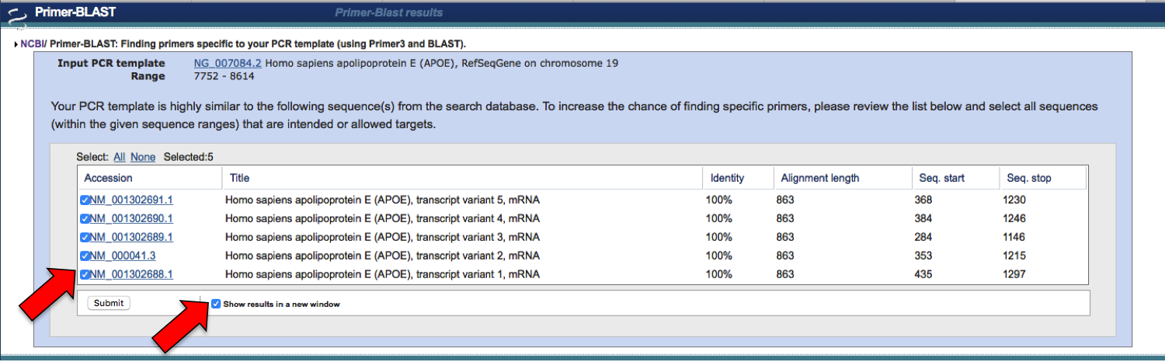

1. This time the tool found two possible primer pairs; the first pair spans the first part of exon 4, while the second spans the end of exon 4. We know from previous studies that isoforms of APOE differ from each other in the part of exon 4 covered by the first primer pair, so we’ll choose those for our reaction. Of course, if multiple different primer pairs were identified that covered the same region, it’s not a bad idea to order all of them and try them all out to see what works best. Primers are pretty inexpensive, so it’s not a big deal to order a bunch; and there’s no guarantee that a particular pair will actually work in real life, even when designed computationally as we have done here, so better to be safe than sorry and test multiple different primer pairs to see which pair works best.

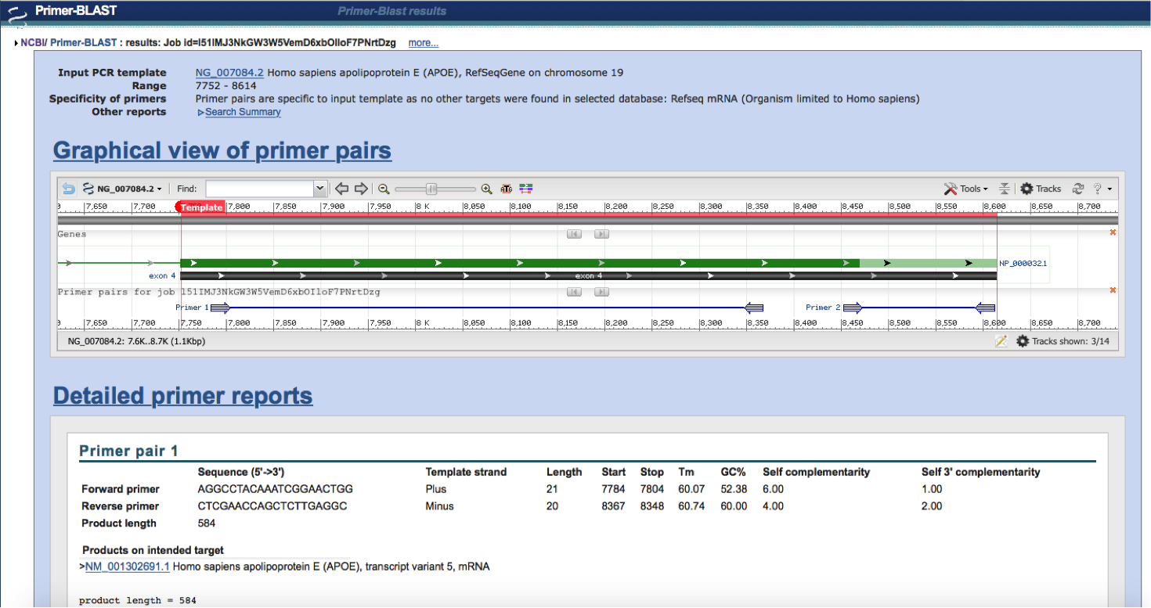

1. If you have the time, it may also be a good idea to cross-check a particular primer pair using different primer design tools; google “primer design tool” and a bunch of different options will pop up. Test the primer pair we found against the APOE gene; you can use the NCBI accession number to reference the sequence. You can also test the primer pair against databases of all known human sequences, to see if the primers will non-specifically amplify other genes.

Now it’s time to order the primers; there are a TON of different commercial vendors available (Thermo Fisher, IDT, Eurofins, Sigma Aldrich, etc.); some universities even have core facilities that offer their own primer synthesis services. Whichever you decide to choose, the process will roughly be the same.

1. Go to the vendor website page for ordering primers; the website may also refer to primers as oligos, or custom DNA oligos, these are the same (google “order primers” and a list of sites should come up)
2. If you’re just starting out, select the option for “standard oligos”; once you’ve got some more experience, you can think about adding modifications to the primers for certain applications
3. On the order page, you should have the option to enter in the primer name and choose some parameters for how they’ll make the primers, such as the scale of the synthesis, the mode of purification, and the format they’ll provide the primer to you. There may be some default settings; stick with those for starters, or use the following as a guide:
   1. Scale: 25nmol
   2. Purification: Desalted
   3. Format: Liquid, at least 15uM if possible
4. After entering this information, you’ll also of course need to enter the actual nucleotide sequence of the primer in the 5’ → 3’ direction.
5. After entering in all the necessary info for the order, proceed to checkout and place the order; primers shouldn’t be more than a few dollars each.
6. Upon delivery and receipt of the primers, proper storage information should be provided, but generally primers that are liquid should be stored in the freezer (-20°C) or the fridge (4°C), while dry primers (which can be reconstituted in water later to get the desired concentration) can be stored at room temperature (~21-27°C).

**Citations**

Ye, J., Coulouris, G., Zaretskaya, I., Cutcutache, I., Rozen, S., Madden, T. (2012) Primer-BLAST: A tool to design target-specific primers for polymerase chain reaction. BMC Bioinformatics 13:134.